**INTRODUCTION**

**What is Data Mining?**

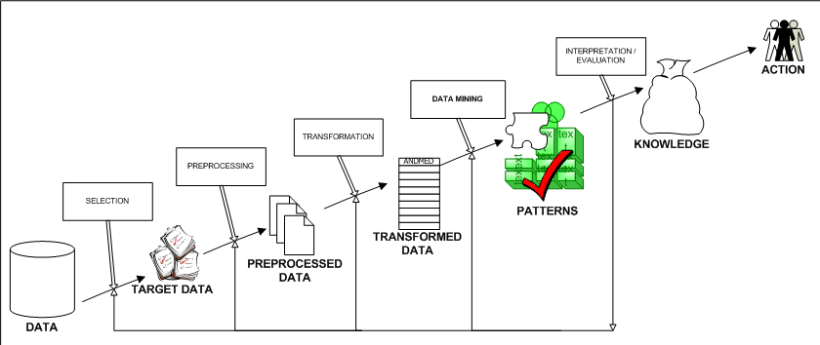

Structure of Data Mining

Generally, data mining (sometimes called data or knowledge discovery) is the process of analyzing data from different perspectives and summarizing it into useful information - information that can be used to increase revenue, cuts costs, or both. Data mining software is one of a number of analytical tools for analyzing data. It allows users to analyze data from many different dimensions or angles, categorize it, and summarize the relationships identified. Technically, data mining is the process of finding correlations or patterns among dozens of fields in large relational databases.

**How Data Mining Works?**

While large-scale information technology has been evolving separate transaction and analytical systems, data mining provides the link between the two. Data mining software analyzes relationships and patterns in stored transaction data based on open-ended user queries. Several types of analytical software are available: statistical, machine learning, and neural networks. **Generally, any of four types of relationships are sought:**

* **Classes**: Stored data is used to locate data in predetermined groups. For example, a restaurant chain could mine customer purchase data to determine when customers visit and what they typically order. This information could be used to increase traffic by having daily specials.
* **Clusters**: Data items are grouped according to logical relationships or consumer preferences. For example, data can be mined to identify market segments or consumer affinities.
* **Associations**: Data can be mined to identify associations. The beer-diaper example is an example of associative mining.
* **Sequential patterns**: Data is mined to anticipate behavior patterns and trends. For example, an outdoor equipment retailer could predict the likelihood of a backpack being purchased based on a consumer's purchase of sleeping bags and hiking shoes.

**Data mining consists of five major elements:**

1. Extract, transform, and load transaction data onto the data warehouse system.
2. Store and manage the data in a multidimensional database system.
3. Provide data access to business analysts and information technology professionals.
4. Analyze the data by application software.
5. Present the data in a useful format, such as a graph or table.

**Different levels of analysis are available:**

* **Artificial neural networks**: Non-linear predictive models that learn through training and resemble biological neural networks in structure.
* **Genetic algorithms**: Optimization techniques that use process such as genetic combination, mutation, and natural selection in a design based on the concepts of natural evolution.
* **Decision trees**: Tree-shaped structures that represent sets of decisions. These decisions generate rules for the classification of a dataset. Specific decision tree methods include Classification and Regression Trees (CART) and Chi Square Automatic Interaction Detection (CHAID). CART and CHAID are decision tree techniques used for classification of a dataset. They provide a set of rules that you can apply to a new (unclassified) dataset to predict which records will have a given outcome. CART segments a dataset by creating 2-way splits while CHAID segments using chi square tests to create multi-way splits. CART typically requires less data preparation than CHAID.
* **Nearest neighbor method**: A technique that classifies each record in a dataset based on a combination of the classes of the *k* record(s) most similar to it in a historical dataset (where *k*=1). Sometimes called the *k*-nearest neighbor technique.
* **Rule induction**: The extraction of useful if-then rules from data based on statistical significance.
* **Data visualization**: The visual interpretation of complex relationships in multidimensional data. Graphics tools are used to illustrate data relationships.

**Characteristics of Data Mining:**

* **Large quantities of data**: The volume of data so great it has to be analyzed by automated techniques e.g. satellite information, credit card transactions etc.
* **Noisy, incomplete data**: Imprecise data is the characteristic of all data collection.
* **Complex data structure**: conventional statistical analysis not possible
* **Heterogeneous data stored in legacy systems**

**Benefits of Data Mining:**

1. It’s one of the most effective services that are available today. With the help of data mining, one can discover precious information about the customers and their behavior for a specific set of products and evaluate and analyze, store, mine and load data related to them
2. An analytical CRM model and strategic business related decisions can be made with the help of data mining as it helps in providing a complete synopsis of customers
3. An endless number of organizations have installed data mining projects and it has helped them see their own companies make an unprecedented improvement in their marketing strategies (Campaigns)
4. Data mining is generally used by organizations with a solid customer focus. For its flexible nature as far as applicability is concerned is being used vehemently in applications to foresee crucial data including industry analysis and consumer buying behaviors
5. Fast paced and prompt access to data along with economic processing techniques have made data mining one of the most suitable services that a company seek

**Advantages of Data Mining:**

### Marketing / Retail:

Data mining helps marketing companies build models based on historical data to predict who will respond to the new marketing campaigns such as direct mail, online marketing campaign…etc. Through the results, marketers will have appropriate approach to sell profitable products to targeted customers.

Data mining brings a lot of benefits to retail companies in the same way as marketing. Through market basket analysis, a store can have an appropriate production arrangement in a way that customers can buy frequent buying products together with pleasant. In addition, it also helps the retail companies offer certain discounts for particular products that will attract more customers.

### Finance / Banking

Data mining gives financial institutions information about loan information and credit reporting. By building a model from historical customer’s data, the bank and financial institution can determine good and bad loans. In addition, data mining helps banks detect fraudulent credit card transactions to protect credit card’s owner.

### Manufacturing

By applying data mining in operational engineering data, manufacturers can detect faulty equipments and determine optimal control parameters. For example semi-conductor manufacturers has a challenge that even the conditions of manufacturing environments at different wafer production plants are similar, the quality of wafer are lot the same and some for unknown reasons even has defects. Data mining has been applying to determine the ranges of control parameters that lead to the production of golden wafer. Then those optimal control parameters are used to manufacture wafers with desired quality.

### Governments

Data mining helps government agency by digging and analyzing records of financial transaction to build patterns that can detect money laundering or criminal activities.

1. **Law enforcement:**

Data mining can aid law enforcers in identifying criminal suspects as well as apprehending these criminals by examining trends in location, crime type, habit, and other patterns of behaviors.

1. **Researchers:**

Data mining can assist researchers by speeding up their data analyzing process; thus, allowing those more time to work on other projects.